BIRLA INSTITUTE OF TECHNOLOGY AND SCIENCE, PILANI


CAD FOR IC DESIGN
(Semester 2, Academic year 2025-26)

Design Project

Systolic Array Matrix Multiplication

Submitted to:
Dr. Abhijit Asati

Submitted By:
Anirudh Shishir (2025H1230098P)
Amit Singh (2025H1230235P)
Nagaraju Aditya (2025H1230216P)
Javalkar Gnanoba Rao (2025H1230236P)

1. Introduction
Matrix multiplication is a fundamental operation widely used in applications such as digital signal processing, machine learning, and scientific computing. Traditional architectures suffer from high latency due to sequential computation. To overcome this limitation, a systolic array architecture is employed, which enables parallel processing and efficient data reuse.
Systolic arrays are a class of parallel computing architectures in which data moves in a synchronized manner across a grid of processing elements (PEs). In matrix multiplication applications, the array is typically organized as a two-dimensional grid of PEs. Each PE consists of:
- A multiplication unit that performs element-wise multiplication
- An accumulation unit that adds the product to a running total
- Storage registers to hold intermediate data and control information
In essence, each PE functions as a MAC (multiply-and-accumulate) unit. For multiplying an m×n matrix with an n×p matrix using an output-stationary approach:
- Elements of matrix A are streamed into the array from the left side
- Elements of matrix B are streamed from the top
- Each PE continuously performs multiply-accumulate operations
- Data from matrix A propagates horizontally (left to right), while data from matrix B moves vertically (top to bottom)
- The final elements of the resulting matrix C are stored in the accumulation registers of the respective Pes
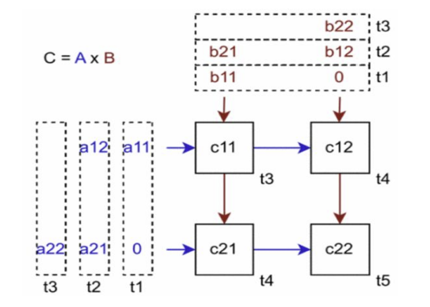
Fig: 2 x 2 Matrix Multiplication using Systolic Array

This project focuses on designing a parameterized systolic array matrix multiplier capable of multiplying two N×N matrices with 8-bit data width and implementing a complete ASIC design flow from RTL to GDS.

2. Aim
To design and implement a systolic array-based matrix multiplier for N×N matrices using 8-bit data width and perform the complete ASIC design flow including RTL design, synthesis, physical design, and GDSII generation.

3. Methodology
The design of the systolic array matrix multiplier follows a structured ASIC design flow, beginning with a parameterized RTL implementation in Verilog HDL and progressing through synthesis, physical design, and final GDSII generation. The top-level module integrates a grid of N × N Processing Elements (Pes), along with row and column FIFOs and a centralized controller to manage data flow and synchronization. Matrix elements are streamed into the array through FIFO buffers, where data propagates horizontally and vertically across the PE network, enabling parallel multiply-accumulate operations. Functional correctness is first verified through simulation using a self-checking testbench. The verified RTL is then synthesized into a gate-level netlist using standard cell libraries under defined timing constraints. Static Timing Analysis (STA) is performed to ensure the design meets setup and hold requirements. The synthesized netlist is subsequently used for physical design, including floorplanning, placement, clock tree synthesis, and routing, ensuring optimal utilization of area and timing performance. Finally, design rule checks (DRC) and layout versus schematic (LVS) verification are carried out to confirm manufacturability and correctness, after which the finalized layout is exported as a GDSII file, completing the ASIC implementation flow.

4. Block Diagram

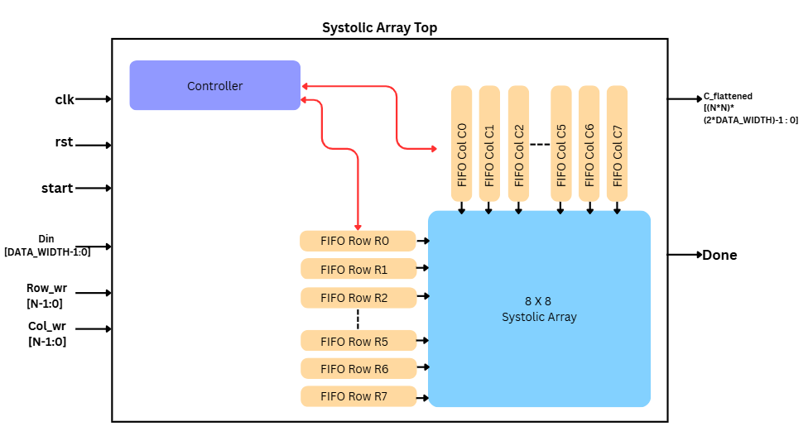

Fig: Block Diagram of the Implementation

- The Above diagram represents a 8 X 8 Systolic Array matrix multiplier designed with N = 8 and data width of elements also of 8 bits.
- The model uses 8 column and 8 row synchronous FIFOs to store the matrices A and B and is sequentially provided as per the controller state. When controller state is in IDLE, there is no multiplication going on.
- Inside the systolic array there are 8 X 8 Processing Elements (PE) which multiply and accumulate the patrix products and stores it.
- Controller has three states IDLE, RUN and DONE.
- When the controller is the in IDLE no multiplication happens, when the controller is in RUN, controller sends the start signal and loads the FIFO contents in to the Processing elements which multiply and accumulates the result in Processing element itself producing matrix multiplication.
- After all the results are computed, controller pulls the done flag high and goes to DONE state.

5. Design Verification:
In this stage, the designed systolic array was tested using simulation to ensure correct functionality. Different matrix inputs were applied through a self-checking testbench, and the outputs were observed using waveforms.
The results showed that the Processing Elements correctly performed multiply-and-accumulate operations, and the final outputs matched the expected matrix multiplication results for all test cases. The controller FSM also transitioned properly between IDLE, RUN, and DONE states.
Additionally, coverage analysis confirmed that most parts of the design were exercised during simulation, indicating thorough verification. Overall, the design was functionally validated without errors.

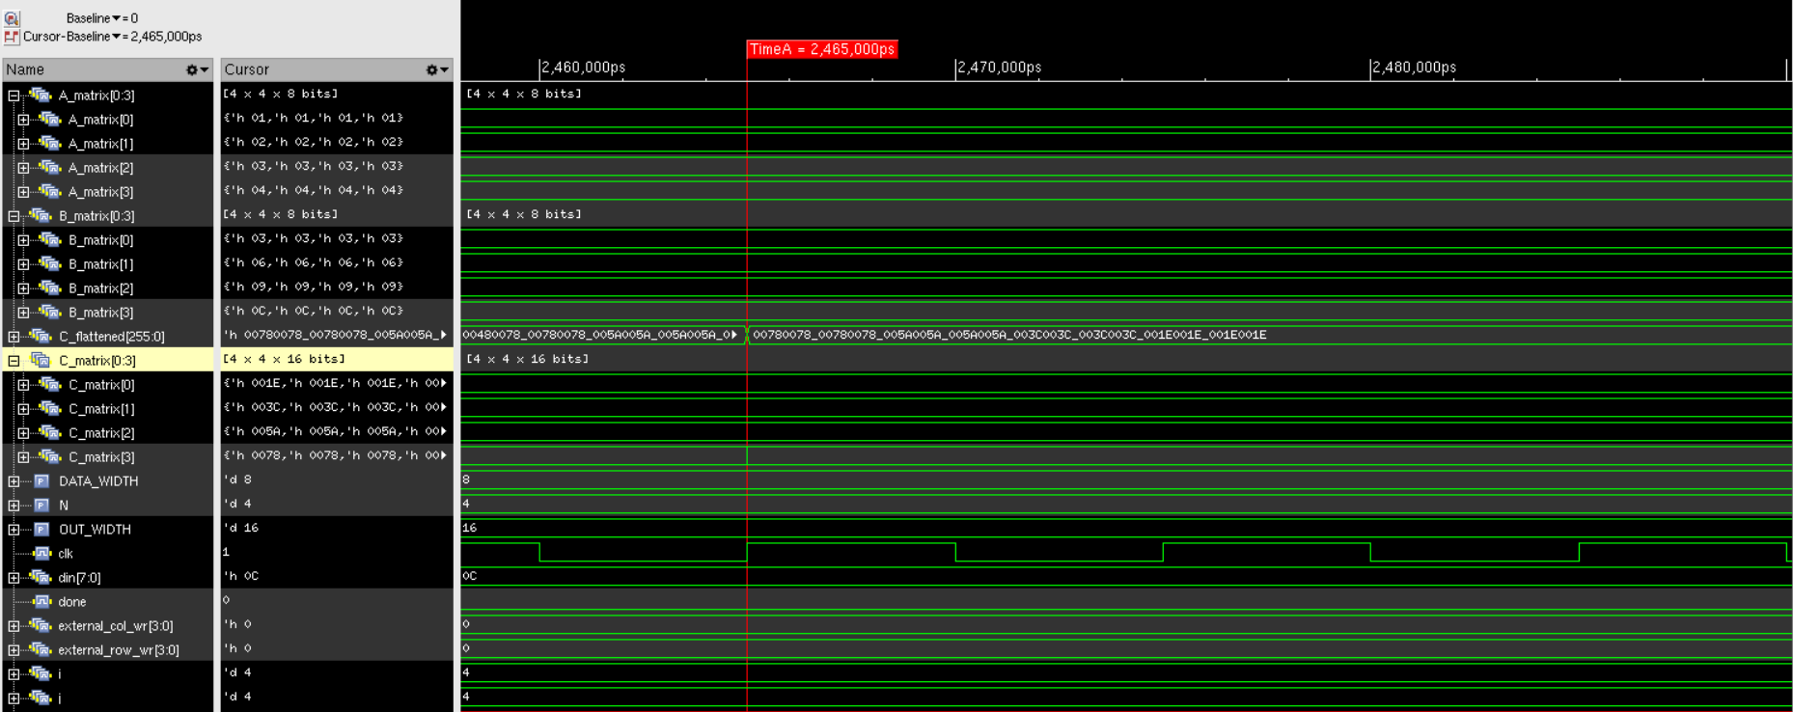
Fig: Waveform for Matrix Multiplication Example-1

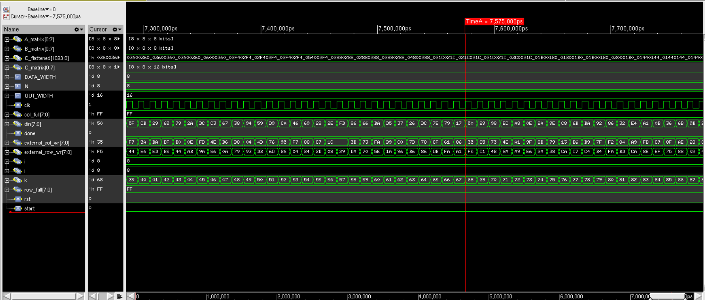
Fig: Matrix Multiplication Example-2

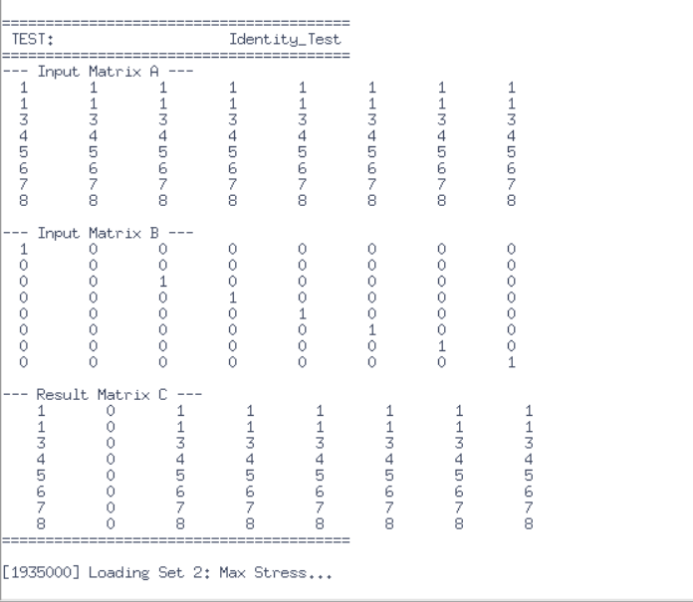
Fig: Matrix Multiplication Examples

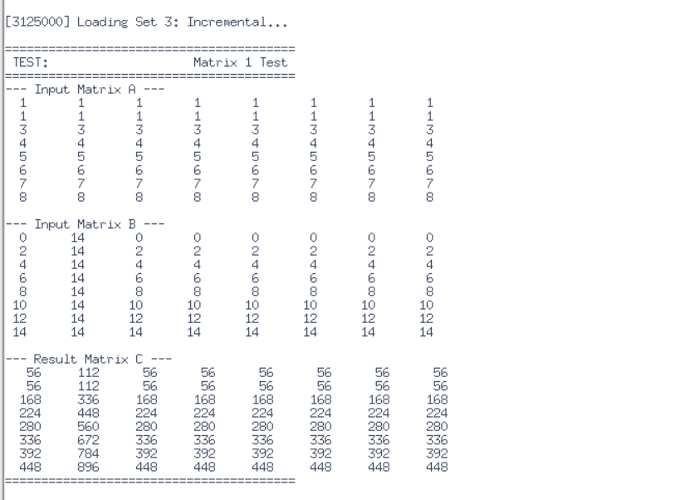
Fig: Matrix Multiplication Examples

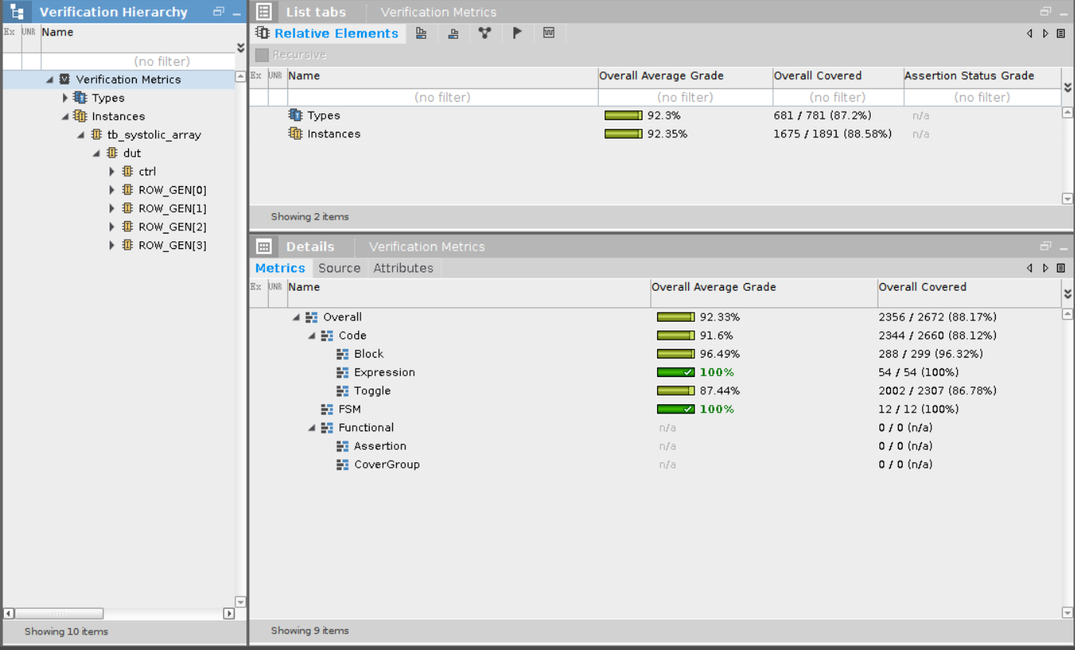
Fig: Coverage Analysis Report

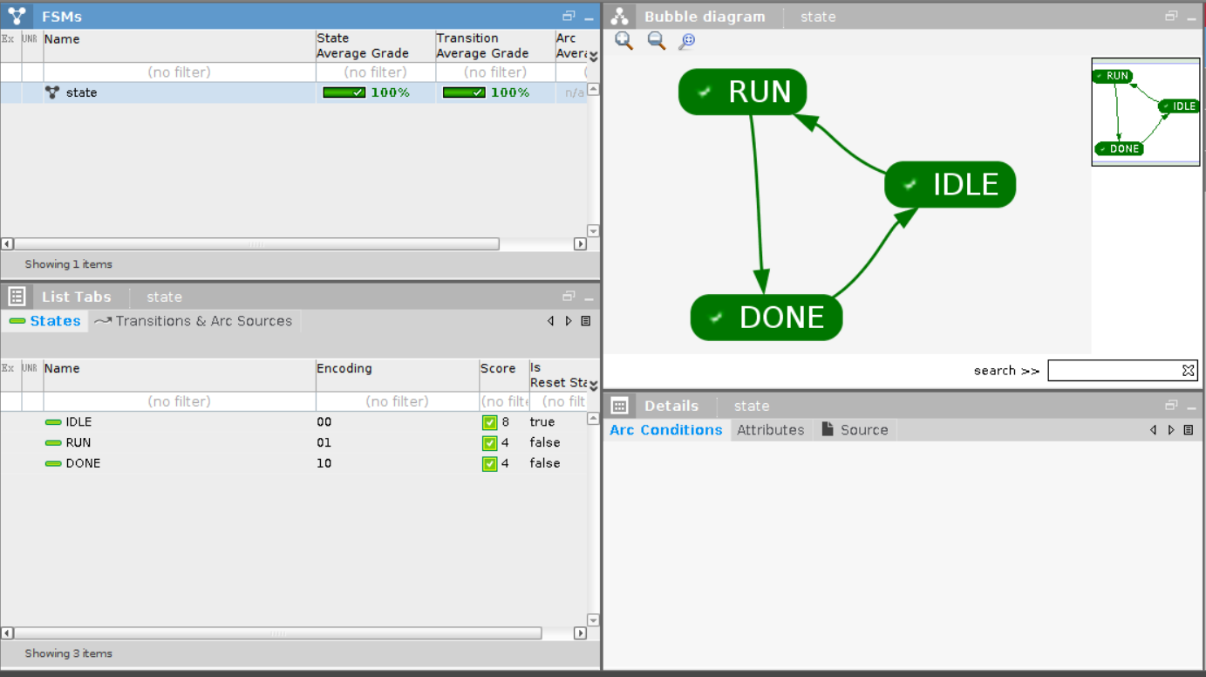
Fig: FSM Report

6. Synthesis:
The verified RTL design was synthesized into a gate-level netlist using standard cell fast.lib under defined timing constraints.
The synthesis results showed that the total design consists of 17,350 cells with a total area of approximately 191,931 units. A major portion of the area (~61.7%) is occupied by combinational logic, while ~37.7% is used by sequential elements such as flip-flops, indicating a heavily pipelined architecture.
The timing reports confirmed that the design meets both setup and hold time requirements, ensuring reliable operation at the target frequency. Power analysis was also performed, providing estimates of dynamic and leakage power.
Overall, synthesis successfully converted the design into an optimized gate-level implementation meeting area, timing, and power constraints.

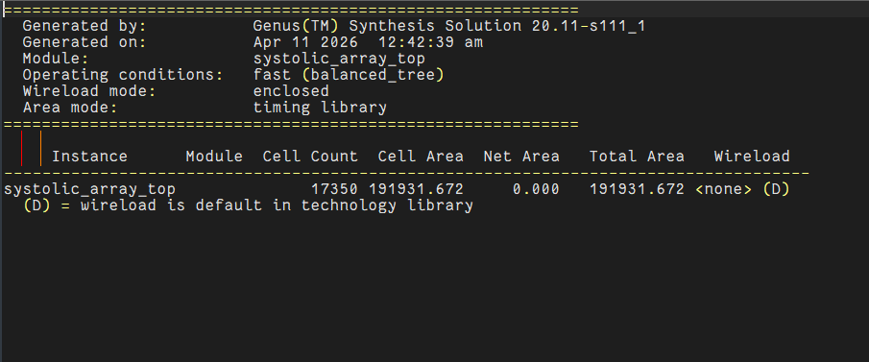
Fig: Area Reports

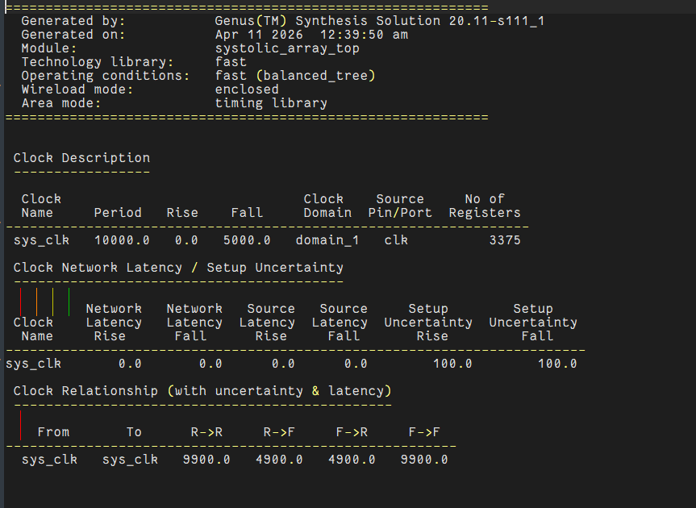
Fig: Clock Reports

Table: Gates Report
Component Type | Instances | Total Area | Area Percentage
Sequential | 3,241 | 72,440.629 | 37.7%
Inverter | 451 | 1,024.086 | 0.5%
Logic | 13,658 | 118,466.956 | 61.7%
Physical Cells | 0 | 0.000 | 0.0%
Grand Total | 17,350 | 191,931.672 | 100.0%

Table: Utilization Reports
Gate Type | Instances | Area | Library
ADDFX1 | 918 | 18,065.688 | fast
ADDFXL | 3,005 | 59,136.594 | fast
AND2X1 | 2,541 | 11,539.697 | fast
AND3X1 | 8 | 48.442 | fast
AOI21X1 | 591 | 2,683.967 | fast
AOI21XL | 31 | 140.783 | fast
AOI221X1 | 128 | 968.832 | fast
AOI222XL | 128 | 1,065.715 | fast
AOI22X1 | 256 | 1,550.131 | fast
AOI22XL | 11 | 66.607 | fast
AOI32X1 | 1 | 6.812 | fast
CLKINVX1 | 186 | 422.350 | fast
INVX1 | 171 | 388.290 | fast
INVXL | 94 | 213.446 | fast
MX2X1 | 11 | 74.933 | fast
MX3XL | 37 | 476.090 | fast
MXI2XL | 166 | 1,005.163 | fast
NAND2BX1 | 192 | 871.949 | fast
NAND2XL | 2,297 | 6,954.397 | fast
NAND3BX1 | 1 | 6.055 | fast
NAND3X1 | 3 | 13.624 | fast
NOR2BX1 | 77 | 349.688 | fast
NOR2BXL | 1,910 | 8,674.074 | fast
NOR2XL | 1,006 | 3,045.766 | fast
NOR3BX1 | 6 | 36.331 | fast
NOR3X1 | 46 | 208.904 | fast
OAI211X1 | 3 | 15.895 | fast
OAI211XL | 16 | 84.773 | fast
OAI21X1 | 203 | 921.904 | fast
OAI22X1 | 3 | 18.166 | fast
OAI2BB1XL | 1 | 5.298 | fast
OAI31X1 | 2 | 12.110 | fast
OAI32X1 | 10 | 68.121 | fast
OAI32XL | 6 | 40.873 | fast
OR2X1 | 15 | 68.121 | fast
SDFFQX1 | 2,129 | 43,508.883 | fast
SDFFQXL | 87 | 1,777.958 | fast
SMDFFHQX1 | 1,025 | 27,153.789 | fast
XNOR2XL | 25 | 208.148 | fast
XOR2XL | 4 | 33.304 | fast
Total | 17,350 | 191,931.672 | —
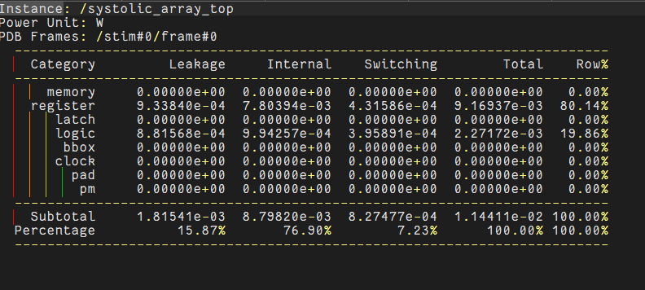
Fig: Power Reports

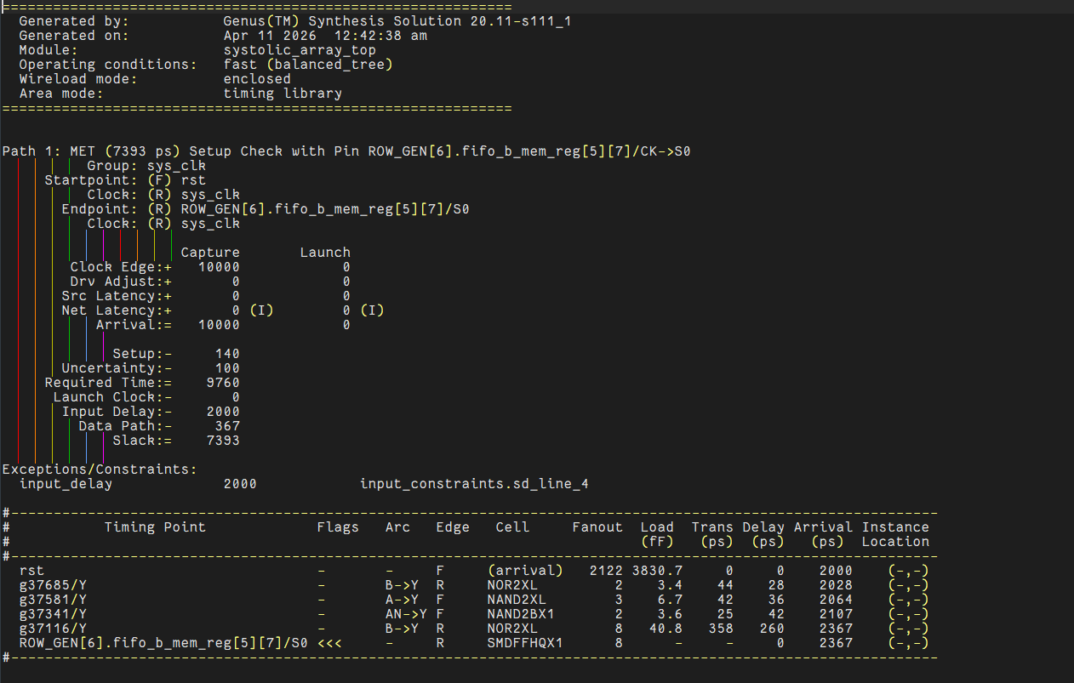
Fig: Timing Report
7. DFT:
Design for Testability (DFT) techniques were applied to make the design testable after fabrication. Scan chains were inserted by connecting flip-flops, allowing test patterns to be shifted through the design.
The fault coverage report indicated a high percentage of detectable faults, demonstrating that the design can be effectively tested for manufacturing defects. The scan chain reports confirmed proper insertion and connectivity.
Overall, the DFT implementation ensured good test coverage and improved reliability of the design.

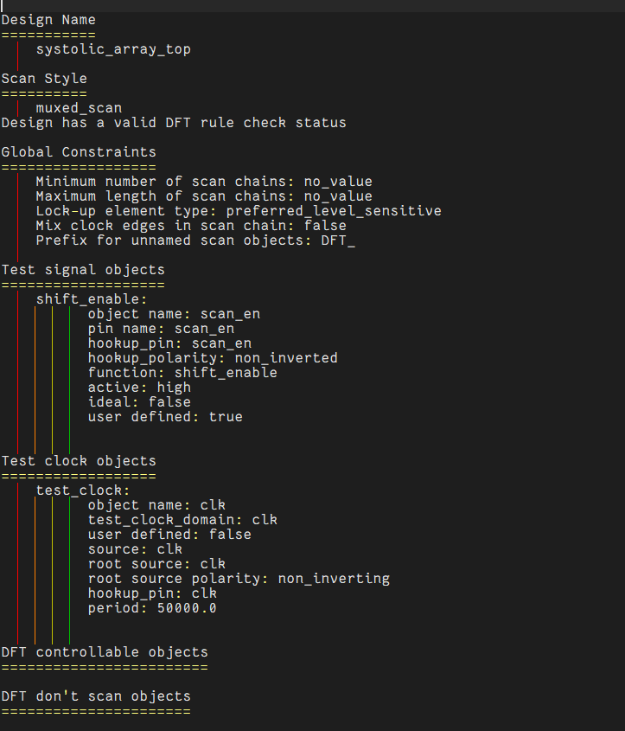
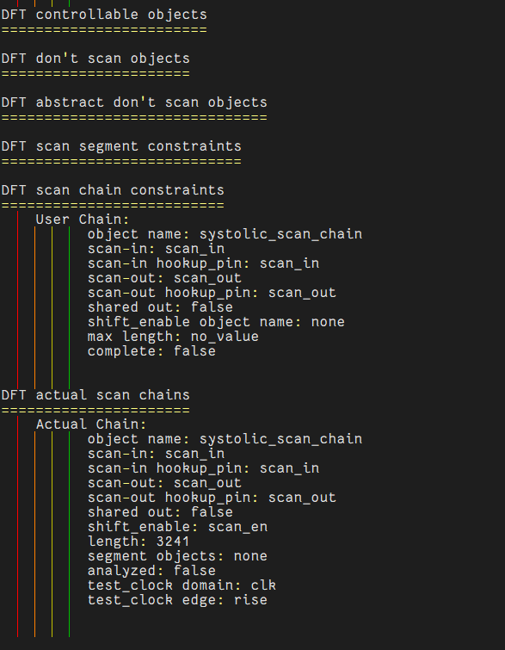
Fig: DFT setup Report

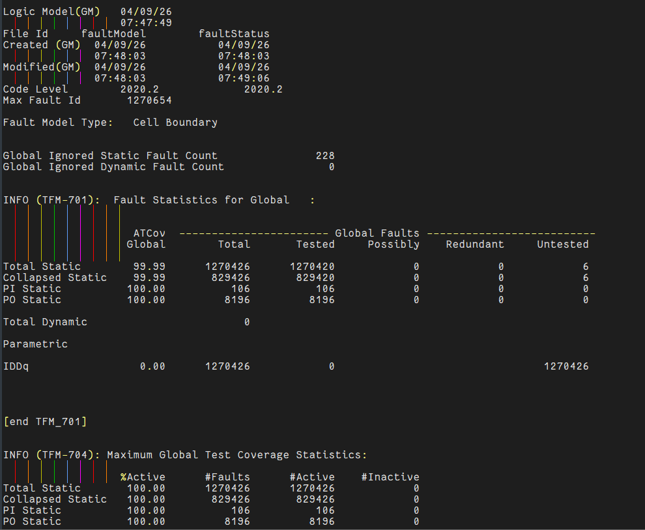
Fig: Fault Coverage

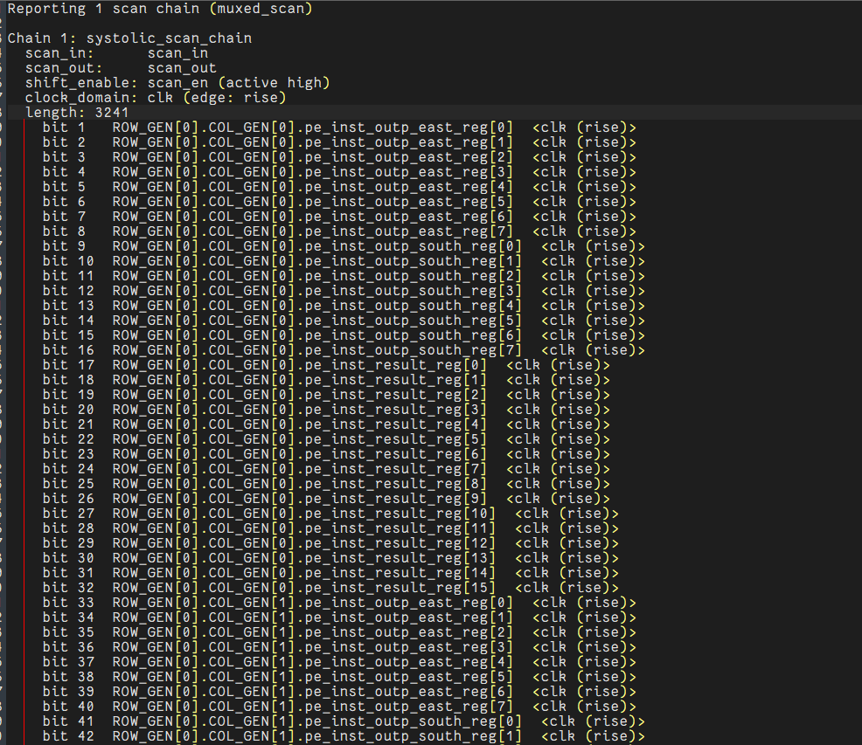
Fig: DFT scan chain Report

8. Implementation:
In this stage, the synthesized netlist was physically implemented. The process included floorplanning, placement of standard cells, clock tree synthesis, and routing.
The placement results showed efficient utilization of chip area, and the clock tree synthesis ensured proper clock distribution with minimal skew. After routing, post-route timing analysis was performed.
The results indicated that both setup and hold timing constraints were satisfied even after routing, confirming that the physical design maintains performance requirements.

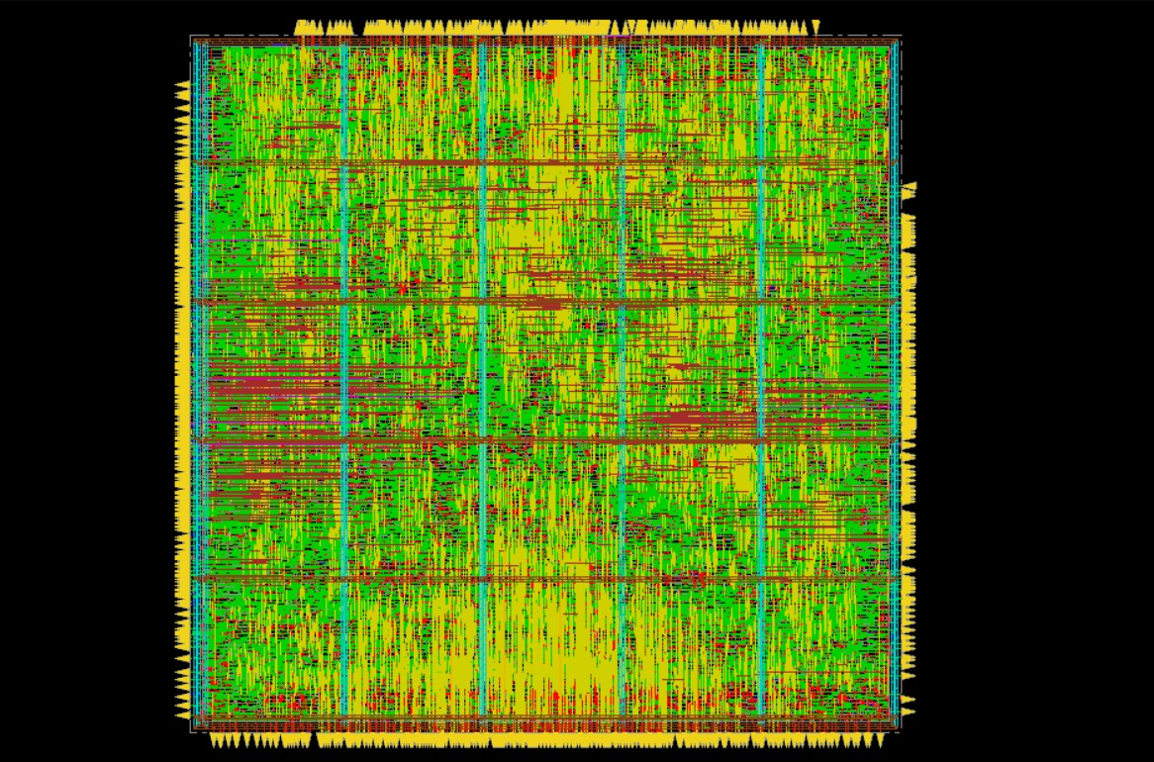
Fig: Implementation and Fully Routed Design

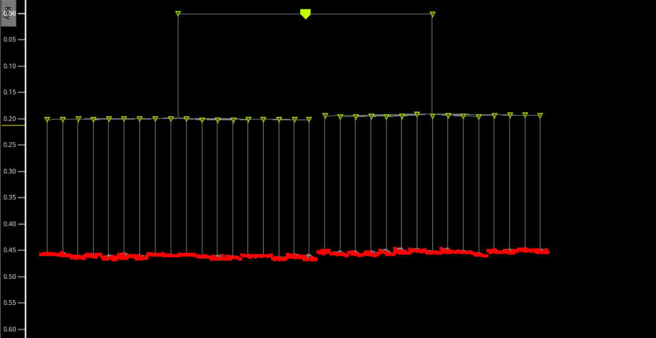
Fig: Clock-Tree-Synthesis

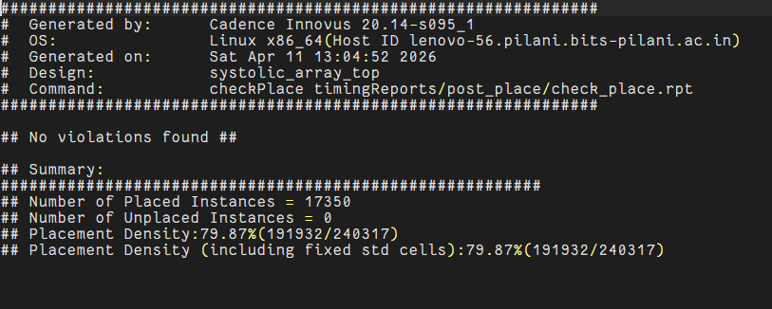
Fig: Placement Report

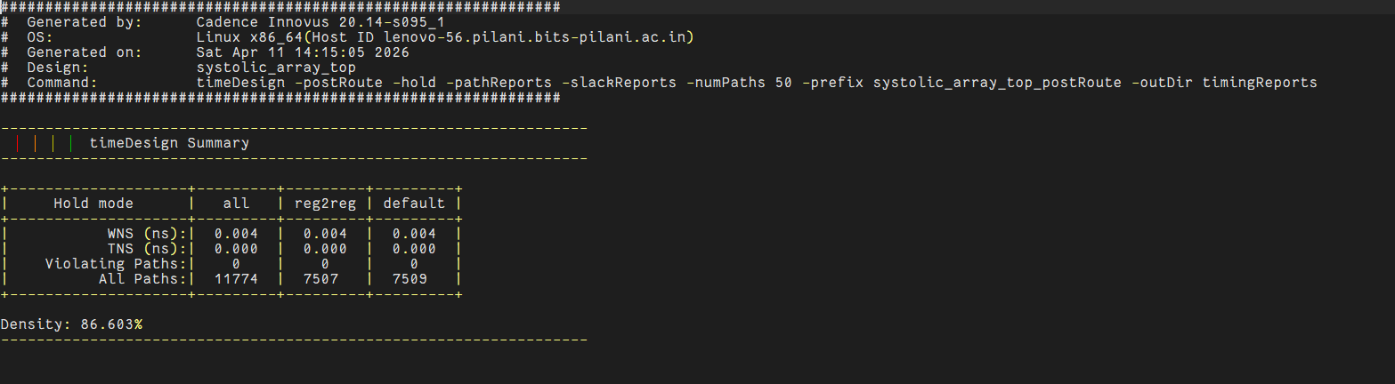
Fig: Post-Route Hold Reports

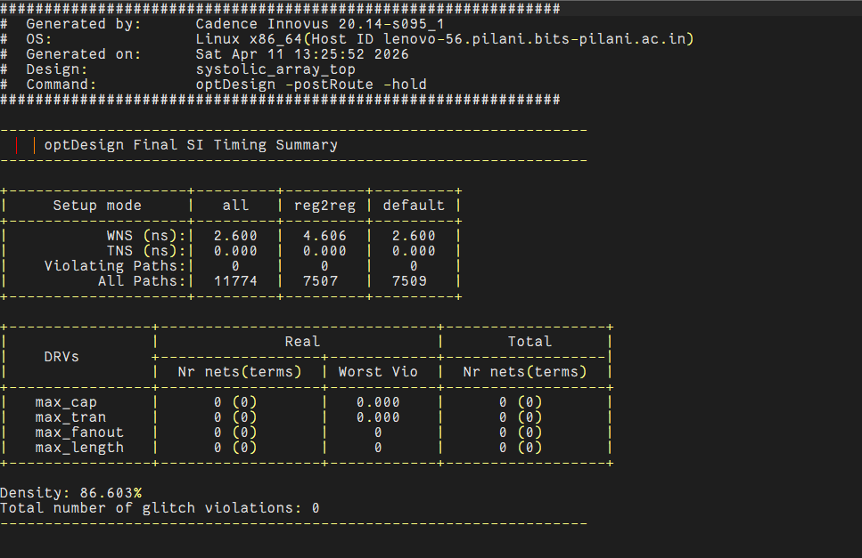
Fig: Post-Route Setup Reports
9. Signoff (timing and power):
Final signoff checks were performed to validate the design before fabrication. Timing analysis confirmed that there were no critical setup or hold violations.
Design Rule Check (DRC) errors identified initially were corrected, and the final layout passed all DRC checks, ensuring manufacturability. Connectivity and geometry checks also passed, confirming that the layout correctly matches the schematic.
Power analysis at the signoff stage verified that the design operates within acceptable power limits.

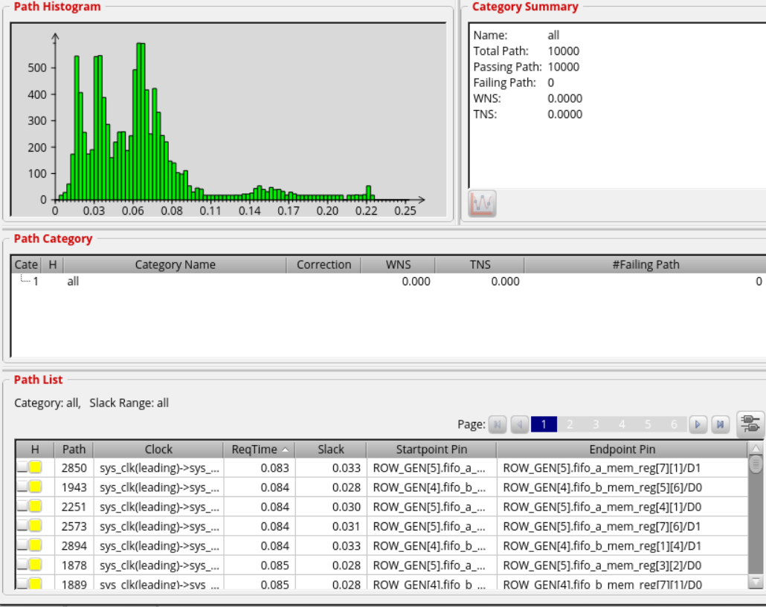
Fig: Setup Violation Histogram Graph

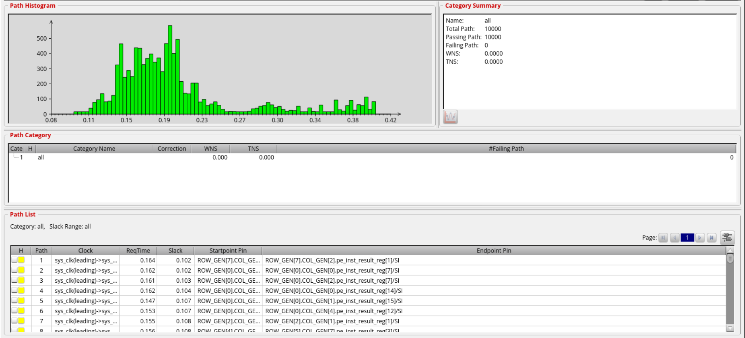
Fig: Hold Violation Histogram

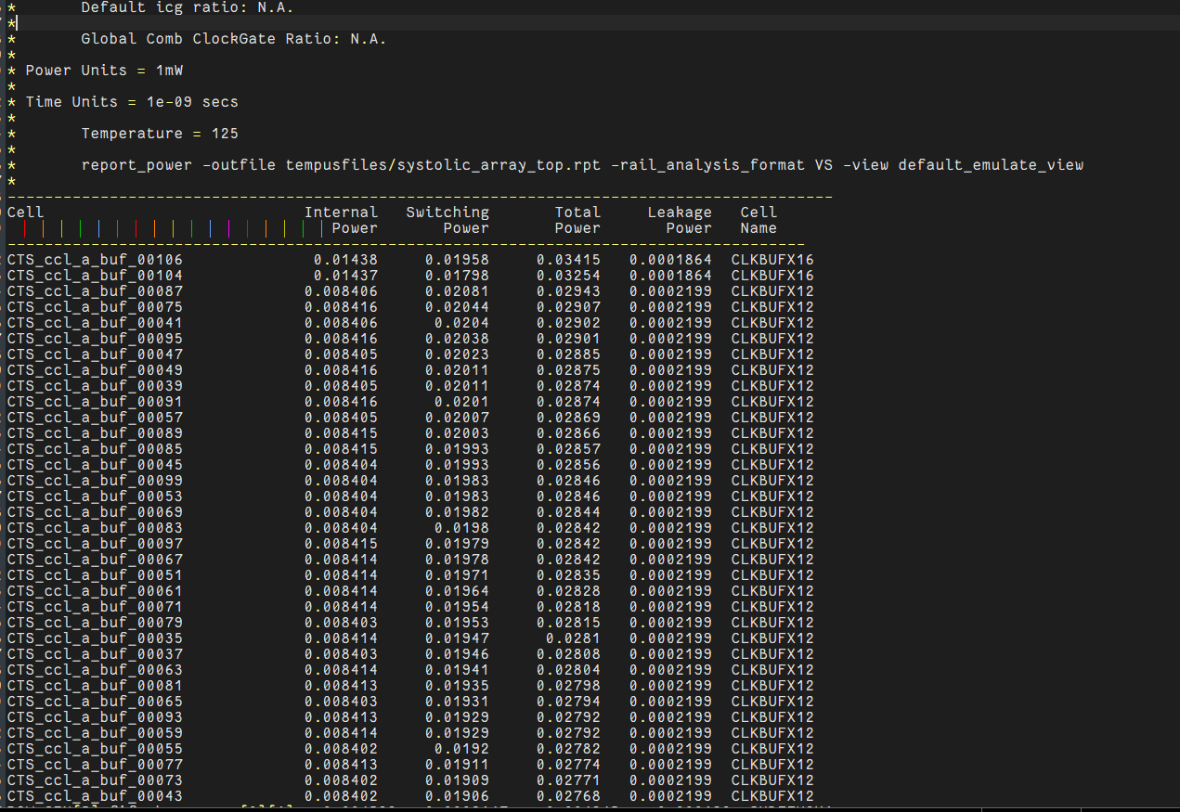
Fig: Power Analysis Report

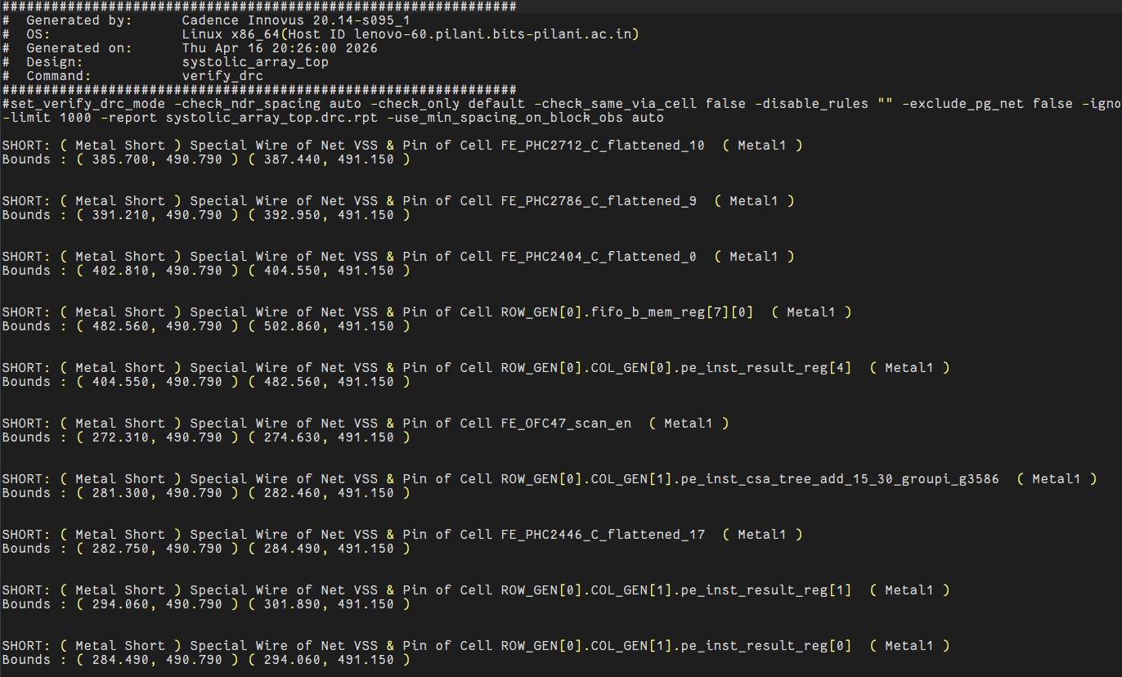
Fig: Old DRC Report

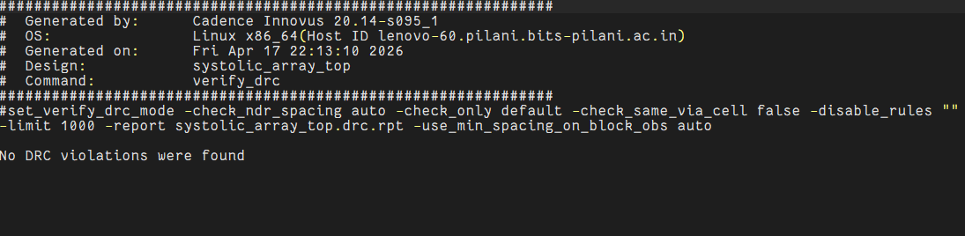
Fig: Recitifed DRC Report

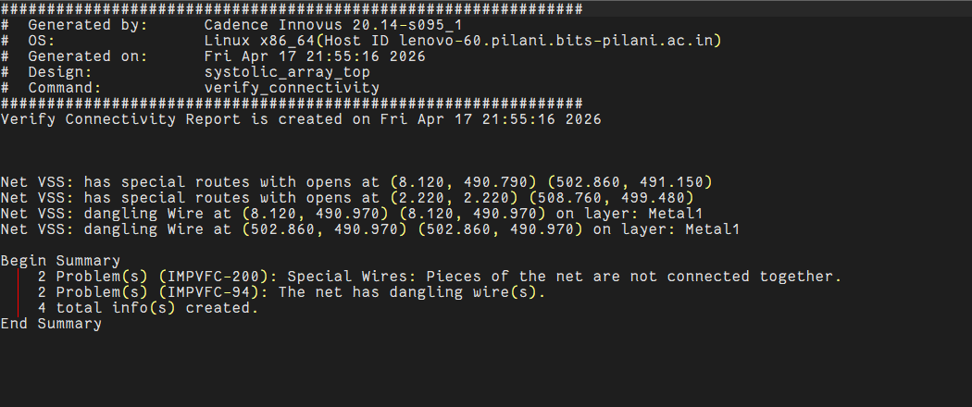
Fig: Old Connectivity Report

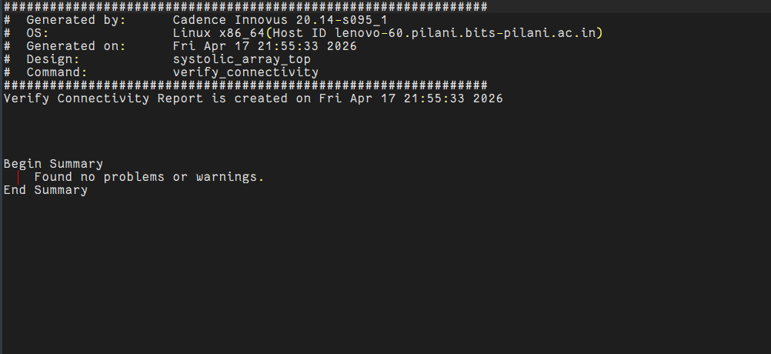
Fig: Rectified Connectivity Report

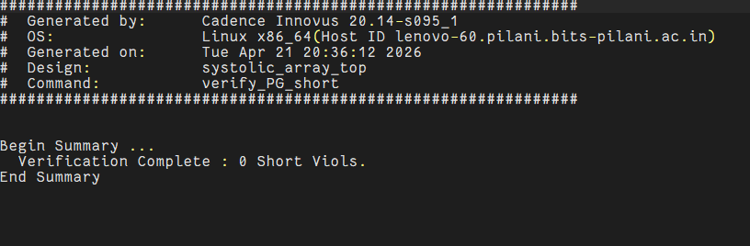
Fig: Rectified Geometry Report

